- The controller panel is wired and plugged in. The interface screen is shown some data in figure below:
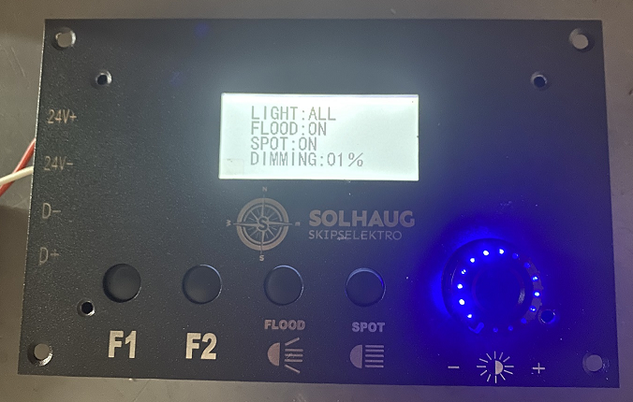
- Turn the rotary knob ( plus/+ )，Luminance brightening。
- Turn the rotary knob (minus/- )，Dimming of brightness。
- Press the (FLOOD) key for wide beam 13ºx52º Oval beam，one press on and the other press off for the flood lighting switching function.
- Press the (SPOT) key for narrow beam 7-8º spot beam，one press on and the other press off for the spot lighting switching function.
- Press the (FLOOD) Key one time and continue press the (SPOT) key for the other time , it is (Flood +spot 7-8º+13x52º) beam angle lighting.

NOTE
If the interface screen doesn't show up anything, you must press F1 + F2 together at the same time.

